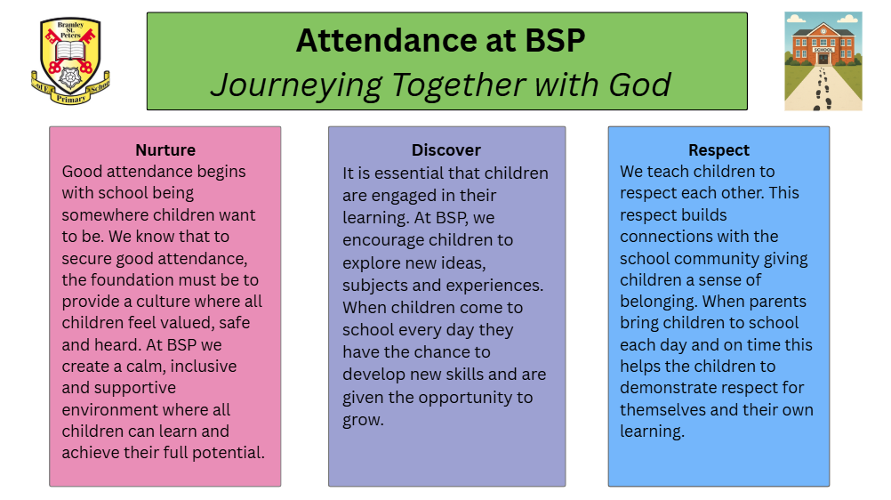
As a school, we aim to support your children to attend well. We acknowledge and celebrate good and improved attendance, and also provide guidance and help to families when needed.
What do we ask from parents and carers?
- Ensure your child attends regularly and arrives at school on time.
- If your child is unwell then you must ring school on each day of their absence. Call 0113 255 9680 and leave a message to inform the school office of an absence.
- Book holidays outside of school time
- Where possible, book medical appointments outside of school time – we will ask for evidence of an appointment e.g. text message, email, copy of a letter etc.
Home Visits
Home visits form part of our process for supporting good attendance and as part of our safeguarding policies and procedures.
The safety, welfare and wellbeing of all our children is paramount and if we deem necessary, we will conduct a home visit. While this list is not exhaustive, these are the typical reasons we would visit a child’s home:
- If parents/carers have not made contact with school
- If school are unable to make contact with parents/carers when a child is absent
- If we have not seen a child for 3 days even when contact has been made
- If a pupil is classed as a persistent absentee – below 90%
- If we have safeguarding/child protection concerns

Punctuality 
- Early Years and KS2 doors open at 8.40am and KS1 doors open at 8.45am. These doors close by 8.55am. If your child arrives after this time, they must go through the main office.
- Once at the office, parents/carers will join an external queuing system which will be overseen by a staff member. They will be asked to explain their reason for lateness and may be provided with a leaflet outlining the importance of being punctual.
The children’s learning begins as soon as the register is complete so if your child is frequently late then they will regularly miss important learning.
See the chart below for good attendance figures – good attendance gives the best chance of success for children


