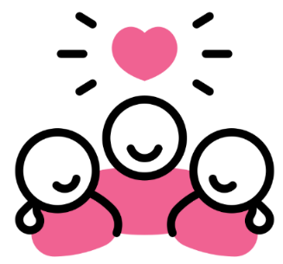

Be Respectful
Use kind words
Use listening ears
Use good manners – say please and thank you
Use kind hands and feet
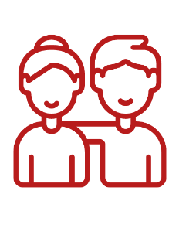
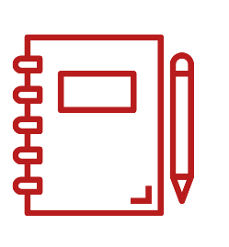
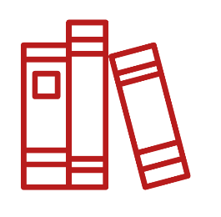
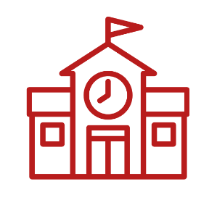

Be Responsible

Take care of our classroom
Remember our book bags and water bottles

Be Ready to Learn
We show 5
Looking eyes
Listening ears
Quiet mouths
Hands still
Feet still

