74 | Autumn 1 | Autumn 2 | Spring 1 | Spring 2 | Summer 1 | Summer 2
Theme | Marvellous Me  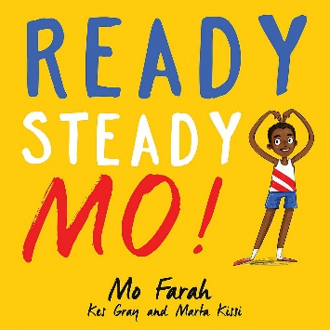  How can we make friends? | Let’s have a party!  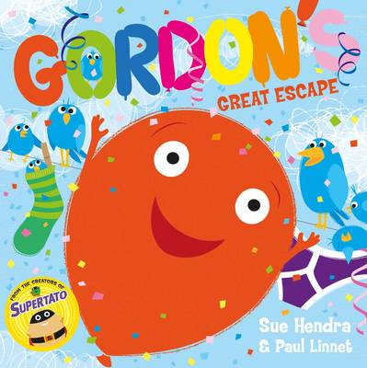  What do we celebrate? | Poles Apart  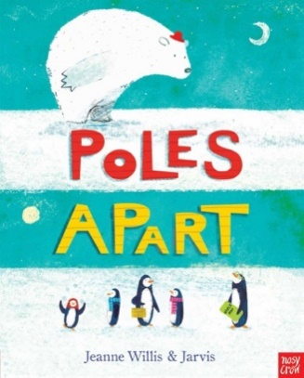  How are the arctic and Antarctic different? | On our way!  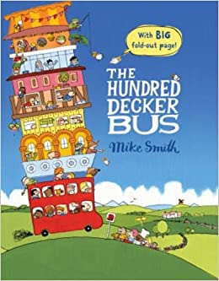  How will we get there? | Down on the Farm  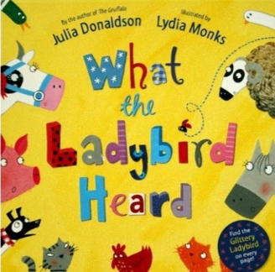  What’s it like inside an egg? | Once Upon a Time  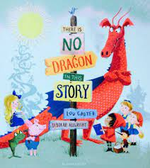  Who lives happily ever after?
Overview | Children will consider what makes them special, how they are unique and how to be a good friend. They will build confidence within the setting, initiating conversations and asking for help when needed. Children will express themselves through being creative and using their imagination; painting a self-portrait and making an all about me book. Children will begin to recognise phase 2 sounds and tricky words and write their name clearly. | Children will demonstrate their understanding around different festivals and celebrations, talking about their own and others experiences. They will be encouraged to develop good listening skills and understanding of other traditions. Children will work part of a group to practise and perform a Nativity play, learning new songs and thinking about why Christmas is important to Christians. Children will plan their own Christmas party. | Children will explore where polar bears live and how it is different to where penguins live. There will be a focus on ice and water, investigating why some objects float and why some objects sink. Children will design and make a boat using a variety of materials and will be encouraged to talk about similarities and differences, patterns and change. Children will build confidence using different tools. | Children will listen to stories about different vehicles; bus, bike, plane, hot air balloon. We will go on a train ride to Eureka where we will explore the world of work, visiting the bank, post office, shops and garage. Children will be encouraged to ask and answer ‘why’ and ‘how’ questions and think about where they live. They will draw and label maps and explore shapes within the environment. Children will design and make a vehicle, becoming confident at assembling and joining materials together. | Children will learn about farmyard animals, showing care and concern for living things – hatching chicks. Children will become familiar with stories by Julia Donaldson, begin to understand more complex sentences and use phonics knowledge to write words and simple sentences. Children will become bakers, using new tools appropriately to make bread and learn about healthy produce and lifestyle. Children will use iPads to support their learning. | Children will wow everyone with their writing as they listen to and create their own stories about dragons, knights, fairies, princesses, giants, and pirates. As children get ready for Year 1 they will think about what makes a super sentence, using capital, letters, full stops and finger spaces. Children will talk about similarities and differences between themselves and confidently share their ideas and thoughts. They will then have their very own Cinderella ball to celebrate their amazing first year at school to reflect on their learning journey so far.
Books for Topic | - What Makes Me a Me  - Just Imagine  - You Choose  - Ready Steady Mo | - Gordon’s Great Escape  - Supertato Carnival-Castro Pea  - Norman the slug who saved Christmas  - Oh! Christmas Tree  - Cake | - Supertato Evil Pea Rules (ee)  - Snowball  - Poles Apart  - The Girl, The Bear and the Magic Shoes  - Lost + Found | - Mrs Armitage on Wheels  - 100 Decker Bus  - The Train Ride  - Emma Janes Aeroplane  - The Great Hot Air Balloon Adventure  - Coming to England  - The Way Back Home | - Sam Plants a Sunflower  - A Squash and a Squeeze  - Dear Zoo  - Chicken  - What the Ladybird Heard  - What the Ladybird Heard Next | - Room on a Broom  - Fairy Tale Pets  - Rapunzel  - There’s no Dragon in this Story  - The Gingerbread Man  - Little Red Riding Hood
Other Key Texts | - The Colour Monster  - When I grow up  - Ready Steady Mo  - Ruby’s Worry  - Max the Brave | - Binny’s Diwali  - Peppa’s Diwali  - I am living in two homes | - Izzy Gizmo and the Invention Creation  - And Tango Makes Three | - The last stop on Market Street  - Daddy, Papa and Me  - Emma and Meesha My Boy; a two mum story | - Egg to Chick  - The Little Red Hen  - Rosie’s Walk  - Worm loves worm | - The princesses have a Ball  - Immanuel's Dream
Communication and Language
ELG – Listening Attention and Understanding  ELG - Speaking | Start a conversation with an adult or a friend and continue it for many turns.  Understand how to listen carefully and why listening is important.  Engage in storytimes  Learn new vocabulary. | Use new vocabulary through the day.  Listen to and talk about stories to build familiarity and understanding.  Ask questions to find out more and to check they understand what has been said to them. | Articulate their ideas and thoughts in well-formed sentences.  Describe events in some detail.  Use talk to help work out problems and organise thinking and activities, and to explain how things work and why they might happen. | Connect one idea or action to another using a range of connectives.  Listen carefully to rhymes and songs, paying attention to how they sound.  Retell the story, once they have developed a deep familiarity with the text; some as exact repetition and some in their own words. | Engage in non-fiction books.  Learn rhymes, poems and songs.  Use new vocabulary in different contexts. | Listen to and talk about selected non-fiction to develop a deep familiarity with new knowledge and vocabulary.
Personal Social and Emotional Development (See planning for Circle Time and Healthy: Inside and Out Days)
ELG – Self-Regulation  ELG – Mangaing Self  ELG – Building Relationships | Become more outgoing with unfamiliar people, in the safe context of their setting.  Show more confidence in new social situations.  Play with one or more other children, extending and elaborating play ideas. | Find solutions to conflicts and rivalries. For example, accepting that not everyone can be Spider-Man in the game, and suggesting other ideas.  Increasingly follow rules, understanding why they are important. Remember rules without needing an adult to remind them | Develop appropriate ways of being assertive.  Talk with others to solve conflicts.  Talk about their feelings using words like ‘happy’, ‘sad’, ‘angry’ or ‘worried’.  Understand gradually how others might be feeling. | See themselves as a valuable individual.  Build constructive and respectful relationships.  Express their feelings and consider the feelings of others | Show resilience and perseverance in the face of challenge.  Identify and moderate their own feelings socially and emotionally. | Think about the perspectives of others.  Manage their own needs.
Physical Development (See Complete PE planning)
ELG – Gross Motor | Refine the fundamental movement skills they have already acquired: rolling, crawling, walking, jumping, running, hopping, skipping, climbing. | Progress towards a more fluent style of moving, with developing control and grace.  Develop overall body strength, co-ordination, balance and agility. | Use their core muscle strength to achieve a good posture when sitting at a table or sitting on the floor.  Combine different movements with ease and fluency.  Develop confidence, competence, precision and accuracy with a ball. | Confidently use a range of large and small apparatus indoors and outside, alone and in a group. | Further develop and refine a range of balls skills including: throwing, catching, kicking, passing, batting and aiming with large and small balls.  Develop confidence, competence, precision and accuracy in ball skills. | Know and talk about the different factors which support their overall health and wellbeing:  Further develop the skills to manage the school day successfully: lining up, mealtimes, personal hygiene.
PE   | Locomotion:  Walking and Jumping | Dance:  Ourselves | Ball skills:  Hands 1 | Gymnastics:  High, Low, Over, Under | Ball skills:  Feet | Attack V Defence:  Games for Understanding
ELG – Fine Motor Skills | Show a preference for a dominant hand.  Be increasingly independent as they get dressed and undressed, for example, putting on coats and doing up zips.  Be increasingly independent in meeting their own care needs, e.g. using the toilet and washing and drying hands. | Develop their small motor skills so they can use a range of tools competently, safely and confidently - pencils, brushes and cutlery. | Use a range of small tools, including scissors, paintbrushes and cutlery with increasing accuracy and competence. | Develop the foundations of a handwriting style which is fast, accurate and efficient.  Draw freely.  Engage in drawing, writing and copying activities. | Develop the foundations of a handwriting style which is fast, accurate and efficient.  Develop pencil grip, letter formation and directionality. | Hold a pencil effectively in preparation for fluent writing –using the tripod grip in almost all cases.  Use a range of small tools, including scissors, paintbrushes and cutlery.  Begin to show accuracy and care when drawing.
Literacy (See writing MTPs)
ELG – Comprehension  ELG – Word Reading  ELG - Writing | Develop phonological awareness.  Engage in extended conversations about stories, learning new vocabulary.  Use some print and letter knowledge in early writing. For example: writing a pretend shopping list that starts at the top of the page; writing ‘m’ for mummy.  Write some or all of their name. | Read individual letters by saying the sounds for them.  Blend sounds into words, so that they can read short words made up of known letter– sound correspondences. | Read some letter groups that each represent one sound and say sounds for them.  Read a few common exception words matched to the phonics phase. | Read simple phrases and sentences made up of words with known letter–sound correspondences and, where necessary, a few exception words. | Re-read these books to build up their confidence in word reading, their fluency and their understanding and enjoyment.  Form lower-case and capital letters correctly  Spell words by identifying the sounds and then writing the sound with letter/s. | Write short sentences with words with known sound-letter correspondences using a capital letter and full stop.  Re-read what they have written to check that it makes sense.
Phonics | Phase 2 | Phase 2 | Phase 3 | Phase 3 | Phase 3 and 4 | Phase 4
Mathematics (See MTPs)
ELG – Number  ELG – Numerical Patterns   | Week 1-3:  Getting to Know You  Baseline Assessments  Key times of day, class routines. Exploring continuous provision. Where do things belong? Positional language.  Week 4-6:  Just Like Me!  Sort – Same/ different, colour, shape, size  Compare amounts – more than, fewer than, equal  Compare size, mass, capacity  Week 7  Consolidation | Week 8-10:  It’s Me 1,2,3!  Introduce 0 and 1  Introduce 2  Introduce 3  Circle and triangles  Positional language  Week 11-13:  Light and Dark  Introduce 4  Introduce 5  Representing numbers to 5  1 more / 1 less  Quadrilaterals and pentagons  Week 14  Consolidation – time related to number 5 and days of the week | Week 1–2:  Alive in 5!  Revise 0/ Composition of 4 and 5  Subitise and partition  Week 3:  Comparing mass  Week 4:  Comparing capacity  Week 5-6:  Growing 6,7,8  Counting 6,7,8  Representing numbers 6,7 8  Partition/ subitise  Making pairs | Week 7-8:  Growing 6,7,8  Combining 2 groups  Comparing length and height  Week 9-11:  Building 9 and 10  Introduce 9 & 10  Partition / subitise to 10  Comparing numbers to 10  Bonds to 10  Week 12:  3D shape  Pattern  Consolidation | Week 1-3:  To 20 and Beyond  Building numbers beyond 10  Counting patterns beyond 10  Spatial reasoning (1)  Week 4-6  First, then, now  Adding more  Taking away  Spatial reasoning (2) | Week 7-9:  Find My Pattern  Doubling  Sharing and grouping  Even and odd  Week 10-12:  On the Move  Deepening understanding  Patterns and relationships  Spatial reasoning (3)  Week 13-14:  Spatial reasoning (4) Mapping  Consolidation
Understanding the World
Ongoing look at the seasons – what is happening around us? Use of timeline to discuss what did we do in September/February? Do you remember when we had an Easter egg hunt?
RE  See MTPs | Unit F4  Being Special  Where do we belong? | Christianity Unit F2  Incarnation  Why do Christians  perform Nativity plays at Christmas? | Christianity Unit F1  God/Creation  Why is the world so  important to Christians? | Christianity Unit F3  Salvation  Why do Christians put a cross on an Easter garden? | Unit F5  Which places are special and why? | Unit F6  Which stories are special and why?
ELG – Past and Present | Talk about members of their immediate family and community.  Drawing their family and talking about the people who are special to them. | Name and describe people who are familiar to them.  Comment on images of familiar situations in the past. Look at photographs of their first Christmas – how have you changed? | Comment on images of familiar situations in the past.  Photographs of the first polar exploration. When do you think this photograph was taken? | Compare and contrast characters from stories, including figures from the past. (Bessie Coleman - pilot)  Compare past and present modes of transport  Sort vehicles into Land, Sea and Air | Comment on images of familiar situations in the past.  Lifecycles – How did the chick/flower look last week?  Farms in the past. Compare/contrast photographs. | Talk about the lives of the people around them and their roles in society.  Know some similarities and differences between things in the past and now, drawing on their experiences and what has been read in class.  Understand the past through settings, characters and events encountered in books read in class and storytelling.
ELG – People Culture and Communities | Understand that some places are special.  Talk about their home or a place that is special to them – why is it special?  Inspirational People: Mo Farah | Recognise that people have different beliefs and celebrate special times in different ways.  Learn about festivals and celebrations – Harvest, Bonfire Night, Remembrance Day, Diwali (4/11), Hanukah (29/11 - 6/12), Christmas. | Recognise some similarities and differences between life in this country and life in other countries.  Who lives in the North/South Pole? How is life different to life in Bramley?  Inspirational people: Lorna Simpson (artist/ photographer) | Recognise some similarities and differences between life in this country and life in other countries.  Floella Benjamin – Coming To England. How was her life different when she came to England?  Inspirational people: Bessie Coleman (pilot), Mai Jemison (Astronaut), Floella Benjamin (Presenter) | Understand that some places are special to members of their community.  RE – What places are special to Christians/ Muslims/Jews? Walk to St Peter’s Church. Why do people visit a church? Visitor to talk about going to Mosque/Synagogue. Why are these places special?  Draw information from a simple map - Map of the farm, map of their journey to school, journey to the church. | Describe their immediate environment using knowledge from observation, discussion, stories, non-fiction texts and maps.  Knows some similarities and differences between different religious and cultural communities in this country, drawing on their experiences and what has been read in class.  Explain some similarities and differences between life in this country and life in other countries, drawing on knowledge from stories, non-fiction texts and (when appropriate) maps.  Inspirational people (linked to sport/ sports day): Althea Gibson (tennis), Mo Farah
ELG – The Natural World | Explore the natural world around them.  Autumn Treasure Hunt Activity - what did you find? What can you see on your way to school? How is it changing? What is happening to the trees? Why are all the leaves falling? Why do you need to bring your hat and scarf to school? Do you bring it in summer? | Understand the effect of changing seasons on the natural world around them.  Ongoing look at the seasons. What is changing? Why do you think it is changing? Daily Calendar and weather check. How is the weather different in different months? | Recognise some environments that are different to the one in which they live.  Why is there so much ice in the polar regions? Why don’t polar bears live in Bramley? What animals live in really hot countries? | Recognise some environments that are different to the one in which they live.  Compare a town to countryside. (Link to Eureka and Canon Hall farm trip.)  On the train – what can you see as we travel? Do things change? Are some bits greener than others? Did you see any animals on the way?  At the farm – Does the farm look like Bramley? What is the same and different about it? | Describe what they see, hear and feel while observing change and discovering the outside world around them.  Plant sunflowers – Class Competition  Chicks – Living Eggs Experience  What other changes can you see outside? Minibeast hunt – where will you find the minibeasts? Is anything else growing in our garden? | Explore the natural world around them, making observations and drawing pictures of animals and plants.  Know some similarities and differences between the natural world around them and contrasting environments, drawing on their experiences and what has been read in class.  Understand some important processes and changes in the natural world around them, including seasons and changing states of matter.
Forest Garden | What can we find? Treasure hunt working in groups | Why do the leaves change colours? Talk about Autumn | Can you build a snowman? Winter walk/ seasonal changes | Which way shall we go? Follow directions/ map making | What was that noise? Listening carefully / using senses | Why is the woodland so magical? Thinking about who/ what lives in the woodland?
Expressive Art and Design
ELG – Creating with Materials  ELG – Being Imaginative and Expressive | Self portraits  Explore artistic effects  Develop colour mixing techniques to enable them to match the colours they want to represent, with step-by-step guidance if necessary. Mix primary colours to make secondary colours.  Begin to use black and white in colour mixing.  ALma Thomas inspired art work  Remember and sing entire songs.  Play instruments with increasing control to express their feelings and ideas. | Create collaboratively, sharing ideas resources and skills.  Design and make a Diwali Candle  Construct with a range of materials  Teach different techniques for joining materials (tape and glue).  Yoyoi Kusana inspired circle pictures  Nativity songs  Listen attentively, move to and talk about music, expressing their feelings and responses. | Design and make a boat  Construct with a range of materials. Explore joining techniques.  Watch and talk about dance and performance art expressing their feelings and responses. | Pop up chick card  Construct with a range of materials and tools.  Easter Songs  Sing in a group or on their own, increasingly matching the pitch and following the melody. | Observational drawings/ paintings of sunflowers/ chicks/ minibeasts.  Develop storylines in their pretend play. Provide props which encourage imagination. | Safely use and explore a variety of materials, tools and techniques. For example, to create beanstalks, dragons, enchanted forests.  Share creations  Make use of props when role playing characters.  Invent, adapt and recount narratives with peers/ teacher.  Sing a range of nursery rhymes and songs.  Perform songs, rhymes, poems and stories and dance.
Role Play  See provision planning | RJR – Home Corner  RPC – Shop and Office | RJR – Home Corner  RPC – Shop and Office/ workshop | RJR – Home Corner  RPC – Shop and Office | RJR – Home Corner  RPC – Shop and Office | RJR – Home Corner  RPC – Shop and Office | RJR – Home Corner  RPC – Shop and Office
Other
Curriculum Enhancements and Experiences | Autumn Walk | Christmas Nativity  Christmas Party | Easter | Introduction to the local library/ school library | School trip to Cannon Hall Farm  Chicks  Walk to St Peter’s Church  RE – Special visitor to talk about places which are special to them | Sports day  Cinderella’s Ball
  Global Links | 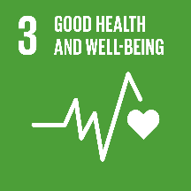  What makes you special? |  | 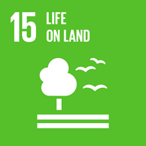  Why is the polar bears ice melting? |  |  | What have you achieved this year?  What are you proud of?

