

Parent Portal

We use Arbor for managing all of our school information including meals, trips, school shop, breakfast and afterschool clubs, uniforms and other payments items.

From September 2026 we will be a cashless school so it is import that you register yourself with a school account for your child. If you have more than one child at the school or at another school that uses Arbor you can simply add your child in reception to that account, otherwise you will need to register for a new one.

We will also be using Arbor for our parental engagement and communications. This will include messages, attendance, Newsletters, urgent message etc so again it is important that we are able to communicate easily with you/ any other guardians.

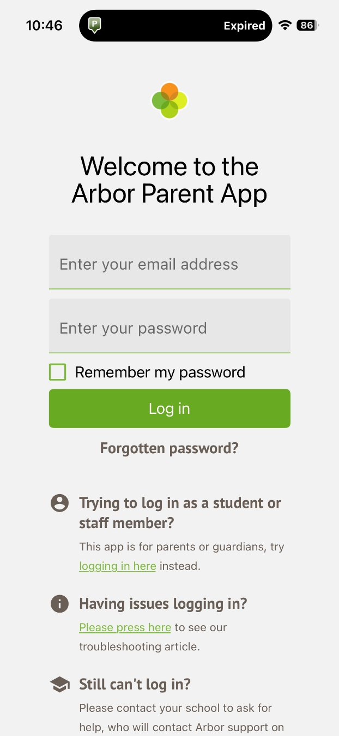
We will shortly be setting you up with an account on the system and will notify you by email when it is time to access your Arbor account.

Once you have received your email asking you to join Arbor, you will need to download the Arbor Parent App from Apple or Google Store to get started.

Don’t worry if you struggle, just call or pop into the school office where we can help or look on the Arbor Website where there is plenty of help and guidance.



